**Task 2: Developing an AI-powered financial chatbot**

Let's get started

In a focused meeting with Aisha, your manager, you're briefed on the next phase of the project. "You've done well with the data analysis," she says. "Now, it's time to build the AI-powered financial chatbot for GFC. This tool will transform the raw data you've worked on into interactive, insightful conversations. Your task is to integrate the analyzed data into the chatbot's framework, making sure it can interpret and relay financial insights effectively."

She makes it clear, "This is a hands-on challenge during which both your coding skills and your understanding of the financial data will be put to the test." Aisha reassures you of her support throughout this process, emphasizing the importance of this development in the project's success.

With a direct approach and clear expectations set, you leave the meeting ready to tackle the task ahead.

# Principles of AI chatbot development

Before you begin, let's ground this task in some necessary understanding.

As we delve into AI chatbot development, it's crucial to grasp the foundational principles that make chatbots effective communicators and problem solvers. At its core, a chatbot is designed to simulate a conversation with human users. For our financial chatbot, this means that the AI should understand and respond to queries about financial data in a way that feels natural and helpful.

**Rule-based logic**: Start by implementing rule-based responses. This means your chatbot will use predetermined responses to specific queries. Think of it as a sophisticated "if-then" logic: if the user asks "X," then the chatbot responds with "Y." This approach is ideal for handling frequently asked questions about financial data.

**State management**: Even in a simple chatbot, managing the conversation's state is important. This involves remembering the context of the conversation or the user's previous queries to make responses more relevant and personalized.

**Error handling**: Prepare your chatbot to handle unrecognized queries gracefully. It should inform users when it doesn't understand a question and guide them towards queries that it can respond to.

# Techniques for integrating financial data with chatbot functionalities

Integrating financial data into your chatbot is about making static data dynamic and interactive. The aim is to transform your previously analyzed financial data into insightful responses that the chatbot can provide when prompted by user queries.

**Data structuring**: Before integrating, ensure your financial data is structured in a way that allows your chatbot to access and interpret it easily. Using formats such as JSON or CSV can be helpful, as you can map data points to specific queries.

**Retrieval methods**: Implement simple retrieval methods that allow your chatbot to fetch the right piece of data based on the user's query. For instance, if a user asks about a company's net income, your chatbot should know how to find and present that specific data point.

**Predefined data points**: Since we're focusing on predefined queries, associate each query with specific data points in your data set. This direct mapping simplifies the process of fetching and presenting data in response to user inputs.

# Communicating complex financial insights

The ultimate goal of your chatbot is to communicate complex financial insights in a way that's accessible and engaging. This involves presenting data in a manner that's informative and easy to understand.

**Simplification and summarization**: Work on simplifying and summarizing financial insights. Use clear, jargon-free language to explain financial concepts or data points. Remember, the user might not have a financial background.

**Interactive dialogue design**: Design your chatbot's dialogue to be interactive. Encourage users to explore different queries by suggesting related topics or asking follow-up questions. This can improve user engagement and make the interaction more informative.

**Visual aids**: While our focus is on text-based interaction, consider describing how data visualization aids such as charts or graphs could be referenced or described by the chatbot to aid in understanding complex data.

By understanding these principles and techniques, you're well on your way to creating a chatbot that communicates in an engaging and user-friendly manner and serves as a bridge between users and financial data. Remember, the key to a successful chatbot is its ability to communicate its findings to enhance user understanding and decision-making.

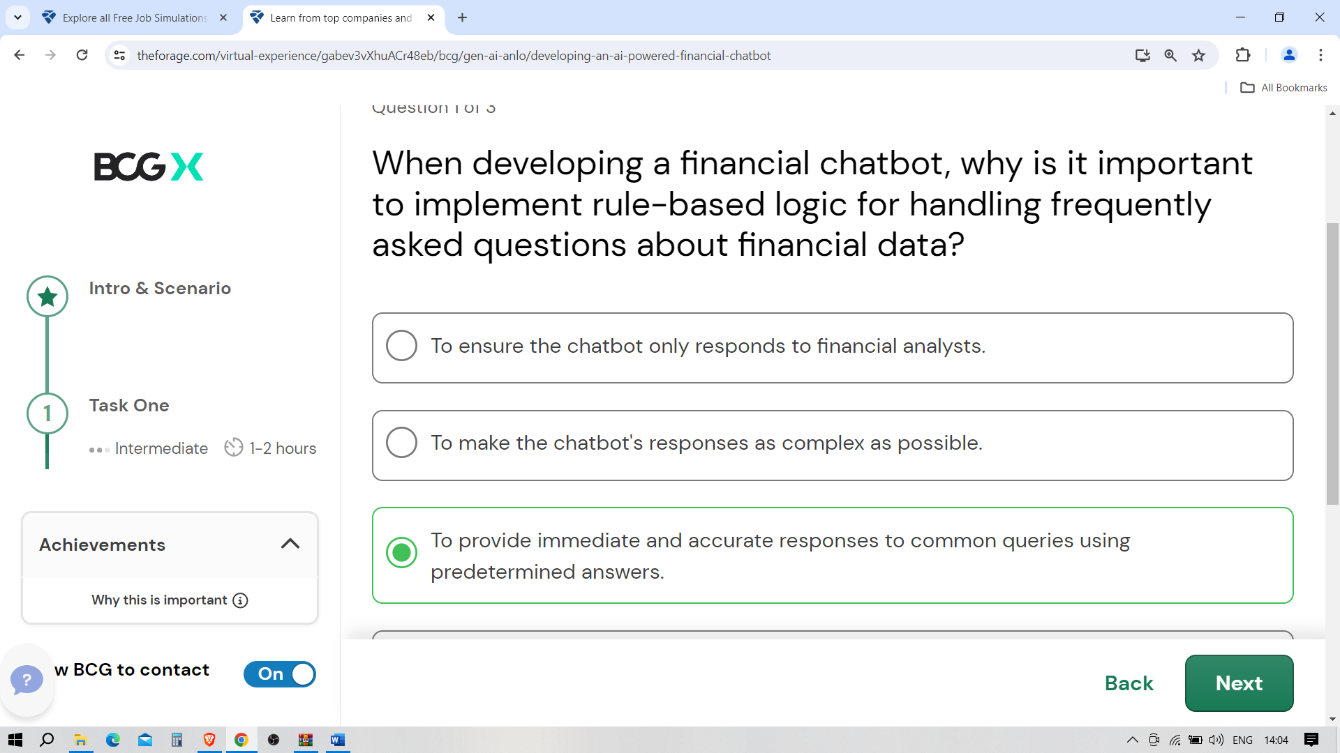

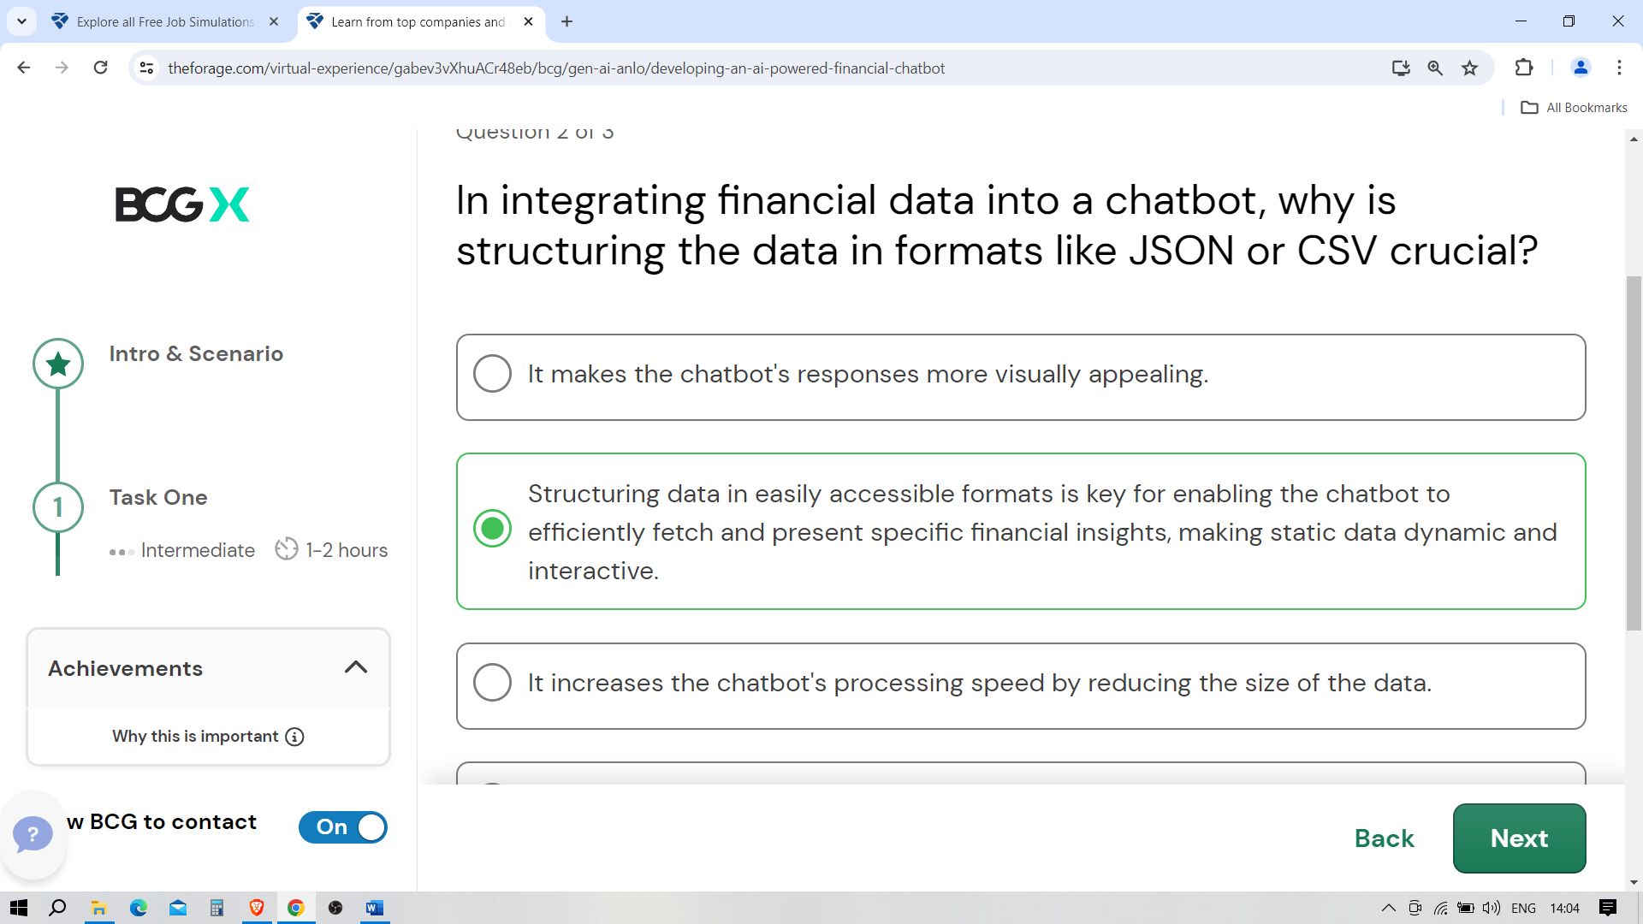

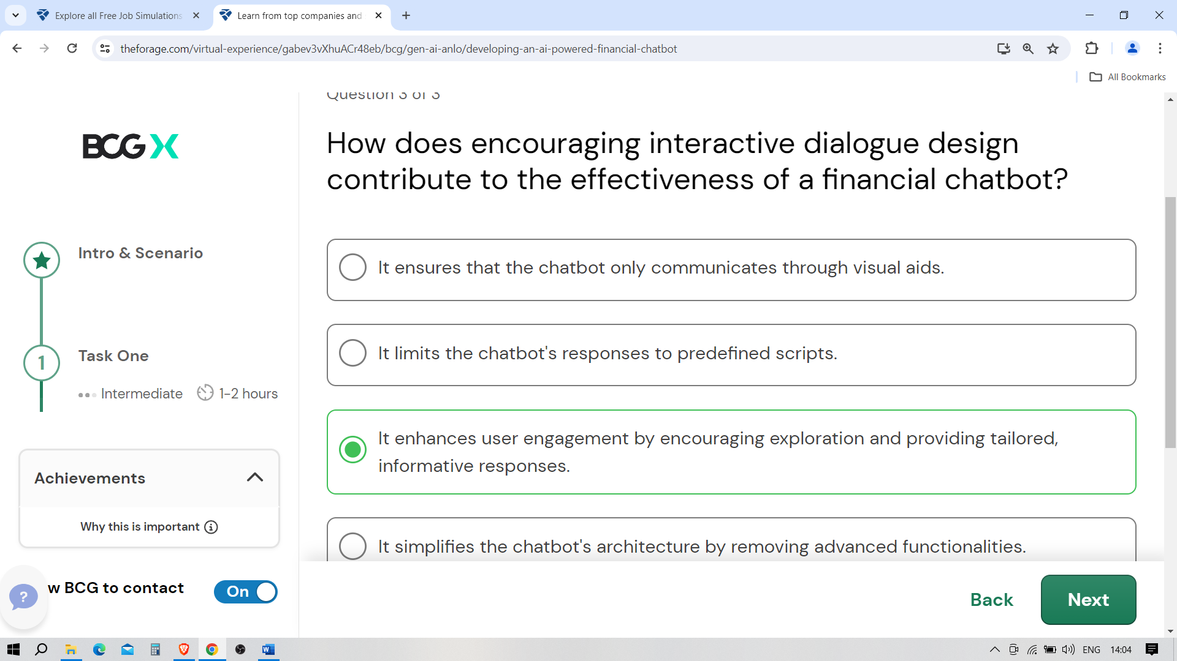

Ready to develop

In BCG's tech hub, your notable achievements in data extraction and analysis have paved the way for a new challenge. Aisha has outlined the next phase of the project: the creation of an AI chatbot that transforms complex financial data into actionable insights. This tool will revolutionize how GFC navigates financial decisions by making intricate data accessible and understandable.

As you embark on this endeavor, it's important to recognize that you're part of a broader, dynamic team, each with specialized roles that contribute to the chatbot's development. Your primary focus will be on implementing rule-based logic, a foundational aspect that ensures the chatbot can respond accurately to a set of predefined financial queries. This task is essential for giving the chatbot its initial "understanding" of user inquiries and its ability to provide immediate, reliable information.

Meanwhile, other team members will tackle different facets of the chatbot's development:

* **Natural language processing (NLP) experts**: Colleagues specializing in NLP are working to refine the chatbot's ability to parse and understand the nuances of human language, enabling it to interact more naturally with users.
* **Machine learning engineers**: This segment of the team is dedicated to incorporating machine learning algorithms that allow the chatbot to learn from interactions, improve its responses over time, and handle more complex queries beyond the rule-based scope.
* **Data integration specialists**: These are team members focused on the seamless integration of financial data, ensuring the chatbot has real-time access to accurate and comprehensive financial information.
* **User experience (UX) designers**: UX designers are ensuring that interactions with the chatbot are intuitive and user-friendly, designing interfaces that make financial insights accessible to all users, regardless of their financial expertise.

Your role in developing the rule-based logic is a critical piece of a much larger puzzle. By focusing on this aspect, you're laying the groundwork for the chatbot's functionality and enabling further developments in AI, machine learning, and user interaction. As you progress, remember that collaboration and communication with your team are key. Your work on rule-based logic sets the stage for the more sophisticated functionalities that your teammates are building, moving us closer to revolutionizing financial analysis for GFC.

Let's get to work!

Chatbot prototype

Building a fully functional AI chatbot for financial analysis is a complex process involving advanced programming and deep learning techniques. However, to fit our learning objectives and time constraints, we've tailored a simplified task. This streamlined version will introduce you to the basics of chatbot development, focusing on creating a prototype that responds to predefined financial queries. It's a first step into the world of AI chatbots, offering a glimpse into their potential without the need for extensive development time or advanced technical skills. Let's begin this journey, keeping an eye on the bigger picture while we tackle this accessible task.

Step 1: Preparation

* **Review the analyzed data**: Quickly review the financial data you analyzed in Task 1 to refresh your memory on what information is available.
* **Set up your environment**: Ensure Python and essential libraries (like **pandas** for data handling and **Flask** for a simple web application, if applicable) are installed.

Step 2: Chatbot design and data preparation

* **Define predefined queries**: Select 3 to 5 common financial queries (e.g., "What is the total revenue?", "How has net income changed over the last year?").
* **Prepare responses**: Use the analyzed financial data to create canned responses for these queries. This step involves mapping each predefined query to a specific response based on your data analysis.

Step 3: Basic chatbot development

* **Chatbot logic**: Write a simple Python script that uses **if-else** statements to match user input (the predefined queries) to the responses you prepared. For a more interactive experience, consider using a basic Python library such as **input()** for command-line interaction or a simple Flask app for web-based interaction.

def simple_chatbot(user_query):

if user_query == "What is the total revenue?":

return "The total revenue is [amount]."

elif user_query == "How has net income changed over the last year?":

return "The net income has [increased/decreased] by [amount] over the last year."

# Add more conditions for other predefined queries

else:

return "Sorry, I can only provide information on predefined queries."

Step 4: Demonstration and documentation

* **Test your chatbot**: Spend a few minutes testing the chatbot with the predefined queries to ensure it responds correctly.
* **Prepare a brief documentation**: Write a short summary explaining how your chatbot works, the predefined queries it can respond to, and any limitations.

Once you've completed the streamlined chatbot task, it's time to compile and submit your work. Please package your Python script, any test results, and a brief documentation of your chatbot's functionality and limitations into a single zip file.

Example answer

Great work! Take a look at the example answer below to see how a professional would have attempted this task. Think about what you did well and how you can improve.

Let's consider a simplified example answer for developing a financial chatbot prototype. This example aims to guide you through the process and principles involved but remember that there's room for creativity and innovation based on your skills and understanding.

Chatbot example: Basic financial inquiry bot

**Objective**: Develop a chatbot that responds to predefined queries about a company's financial performance, specifically focusing on net income and revenue growth.

1. Rule-based logic implementation

**Python code snippet**

def financial_chatbot(query):

responses = {

"net income": "The net income for the fiscal year 2021 was $5 billion, a 10% increase from 2020.",

"revenue growth": "The revenue grew by 8% from 2020 to 2021, reaching $22 billion."

}

return responses.get(query.lower(), "I'm not sure how to answer that. Can you try a different question?")

**Explanation:**This simple Python function uses a dictionary to map user queries to predefined responses. It demonstrates the principle of rule-based logic and error handling by providing a default response when the query does not match.

2. Data structuring and retrieval

**Data structuring**: Assume we have a CSV file named **financial_data.csv** that stores our company's financial information. For this example, the chatbot's responses are hardcoded, but in practice, you would retrieve this information from your structured data source.

**Retrieval method**: While our example does not directly fetch data from a file, in a more advanced scenario, you could use pandas to read the CSV and query the DataFrame for specific information based on the user's input.

3. Communicating financial insights

* **Dialogue design**: The chatbot's responses are crafted to be clear and informative, summarizing complex financial data into easy-to-understand insights. For a more interactive dialogue, you might expand the function to suggest related queries or follow-up for more detail.

Example interaction with the chatbot

**User query**: "What was the net income?"

**Chatbot response**: "The net income for the fiscal year 2021 was $5 billion, a 10% increase from 2020."

**User query**: "Tell me about revenue growth."

**Chatbot response**: "Revenue grew by 8% from 2020 to 2021, reaching $22 billion."

Conclusion and variation:

This example demonstrates the core principles of developing a financial chatbot using rule-based logic. Depending on your depth of understanding and technical skills, there are numerous ways to enhance and expand this prototype. You might integrate more complex NLP features for natural language understanding, connect to real-time financial databases for dynamic data retrieval, or implement machine learning for more nuanced interaction and response generation.

**Key takeaway**: The principles of chatbot development (rule-based logic, data integration, and clear communication) apply regardless of the complexity of your chatbot. This example provides a foundation, but the possibilities are vast, encouraging you to explore and innovate beyond this basic framework.